**IU000133 AI4Media: FlagGAN01**

[](https://git.arts.ac.uk/21036265/yifanfeng)

**Project Overview**

Inspired by [AImoji: AI-generated Emoji](https://process.studio/works/aimoji-ai-generated-emoji/), my project designs to reflect on how AI system can create internationality from existing human identities and cultures. Around the theme “Transnational Artificial Cultures”, my work aims to challenge patriotism symbolized in national or regional flags. In practice, I built a FlagGAN01 upon two generative neural network DCGAN and StyleGAN2 ADA to produce different styles of artificial flags. The overall process is (1) preprocessing input data; (2) training several times modified DCGAN to generate output; (3) test running and fine tuning customized StyleGAN2 ada by using original input; (4) manually selecting good-quality images (approx. 1000) and importing them into customized StyleGAN2 ada; (4) postprocessing all outcome images and presenting them in .gif files.

**Training Process**

Input dataset was collected from [Countryflags.com](https://www.countryflags.com/) that consists of 270 images (250px*250px) with RGB channels. I upscaled each image proportionally to 256*256 resolution due to two reasons: firstly, 256 is a common image value for computer vision training (e.g. ImageNet) and is helpful to increase training speed for a small project; secondly, some pre-trained models are based on 256*256 input images and transfer learning might require same size input.

**FlagGAN01: Part one** [notebook](https://colab.research.google.com/drive/1SODRk6670HY4V26Be4_A7YkCHXlSGNnR?usp=sharing) [outcome](https://drive.google.com/drive/folders/1F4xeTCrMXJARISmJdfAmQD2KYoV8TWJ4)

My DCGAN was constructed upon week 5-01’s lecture. As the dataset (270 data entries) is relatively small, to prevent overfitting, firstly I added Gaussian noise to the input layer. Besides, I inserted four different data augmentation layers. Next, I reduced active convolutional upscaling filters (Cov2D) and set dropout rate of 25% in the discriminator. All these procedures aim to decrease the discriminator’s reactivity to generator’s signal. Following their original DCGAN’s structure (Radford et al., 2015), I also appended BN (Batch Normalization) to each generator’s layer and played around the activation mode in the last layer (“sigmoid” or “tanh”). After training for 7 times (see fig.01), I found that BN was not helpful to produce better results. In the end, I selected ~1000 images (out of approx. 21,000 generated images) as the expected outcome and stored them in the [DCGAN1000 folder](https://drive.google.com/drive/folders/1DCeedEa3wXqmE1iOLEwJ0f5KnwOFB0X4?usp=sharing).

|  |  |  |  |  |  |  |
| --- | --- | --- | --- | --- | --- | --- |
| **No.** | **Epochs** | **Time (min)** | **Computational Environment** | **Activation Mode** | **BN: on/off** | **Result** |
| 1 | 200 | ~16 | Colab | sigmoid | on |  |
| 2 | 250 | ~29 | Colab | sigmoid | on |  |
| 3 | 500 | ~76 | Colab | sigmoid | off |  |
| 4 | 750 | ~25 | Colab | tanh | on |  |
| 5 | 1000 | ~32 | Jupyter lab | tanh | off | Best |
| 6 | 1000 | ~32 | Jupyter lab | sigmoid | on |  |
| 7 | 750 | ~25 | Jupyter lab | sigmoid | on |  |

(Figure 01. model training summary)

**FlagGAN01: Part two**[notebook](https://colab.research.google.com/drive/1KImfZDSffEtrVuPuhPrXQncrWKa5S4q8?usp=sharing) [outcome](https://drive.google.com/drive/folders/1kjYkMsysogk611lZR8jkGb2CWOq9p_mY?usp=sharing)

My FlagGAN01 continues with a StyleGAN2 ada structure. I chose this model because it allows me to finetune generated outcome by twisting argumentation parameters in its discriminator. Also, it seems interesting to compare my results to “[This x Does Not Exist](https://thisxdoesnotexist.com/)” outcome as many of their projects are created with styleGAN.

To match my input data size, I copied the weights from StyleGAN2 ada (ffhq 256). For the fine-tuning part, I have tried different augmentations such as colour and noise and found that the combination of blit and geom can produce the most wanted outcome (see first training output). Other configurations such as X- and Y-mirror were also applied as it would not change my image content. I applied transfer learning to train my original dataset three times. Each iteration took approximately 14 mins to complete and by default it is 50. In total, I test run three times in Google Colab Pro for 8.5, 2.5, and 2.2 hours respectively and interrupted the training after inspecting results. In the end, I chose to resume the first training checkpoint file (tick 40) to train the DCGAN1000 database (as the second and third training shows a hint of overfitting) and it took about 8.2 hours (in total, two times) to finish rendering 30 ticks.

**Discussion**

**FlagGAN01: DCGAN**

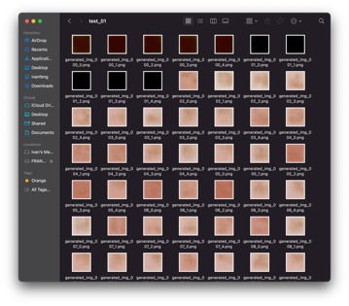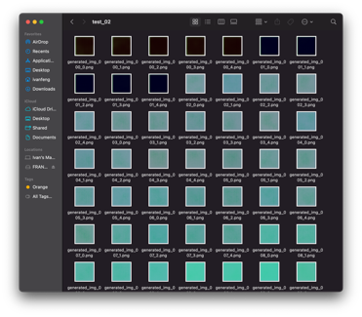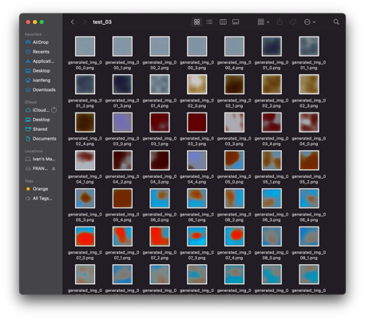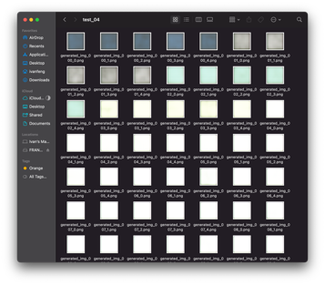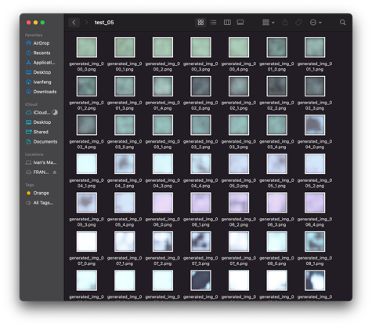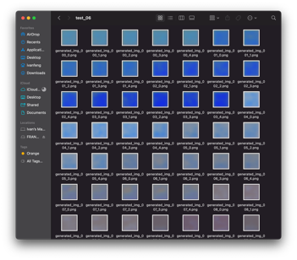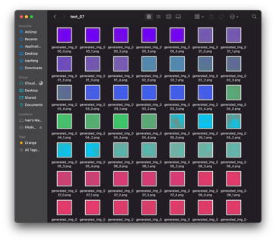

(Figure 02. A quick overview of DCGAN training in sequence)

Figure 2 illustrates AI images after training 10 epochs in FlagGAN01: DCGAN test run 1-7 (from left to right). I firstly noticed that output 3 and 5 (in bigger size) are different than the rest. I turned off batch normalization in training 3 & 5 and the model seems to start learning a second feature: shape from the input flag pictures. A second observation is that “tanh” function compared to “sigmoid” can develop smoother edges and less pixelated (see fig.03) images, but “sigmoid” is good at extracting color property and therefore created more vivid and saturated results. Figure 04 demonstrates a shared learning pathway such as developing strip pattern and star signs after 300 iterations across all trainings. One potential reason is that many input flag images contain these two features.

Figure 05 shows another learning pattern in each training. At the beginning, the model focuses more on color and shapes/edges information from the input. When it comes to the mid/late stage of training, generators try to arrange newly produced patterns to the center to get around discriminator’s detection. My assumption is that the imported flags are cropped and aligned to the middle and generators attempt to imitate their structures. Another assumption is the possibility of mode collapse (see figure 06). The generator seems to learn this way to develop a specific pattern and only replace colour in the pattern to fool the discriminator.

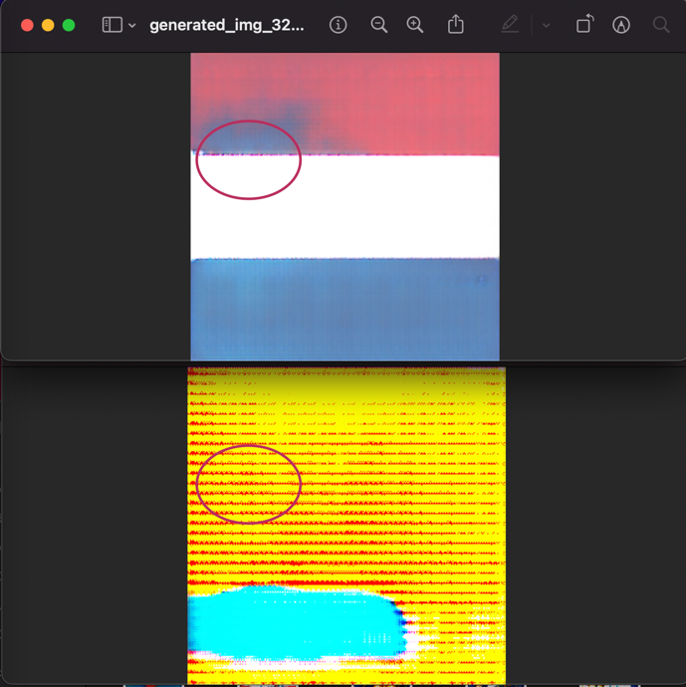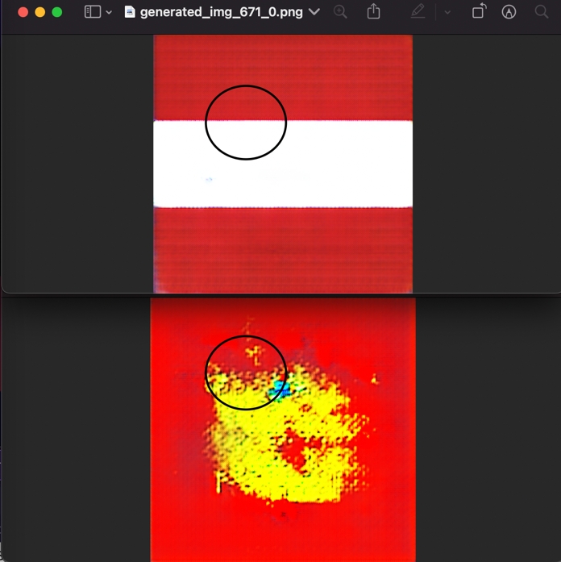

(Figure 03. “tanh” (top) vs. “sigmoid” (bottom) )

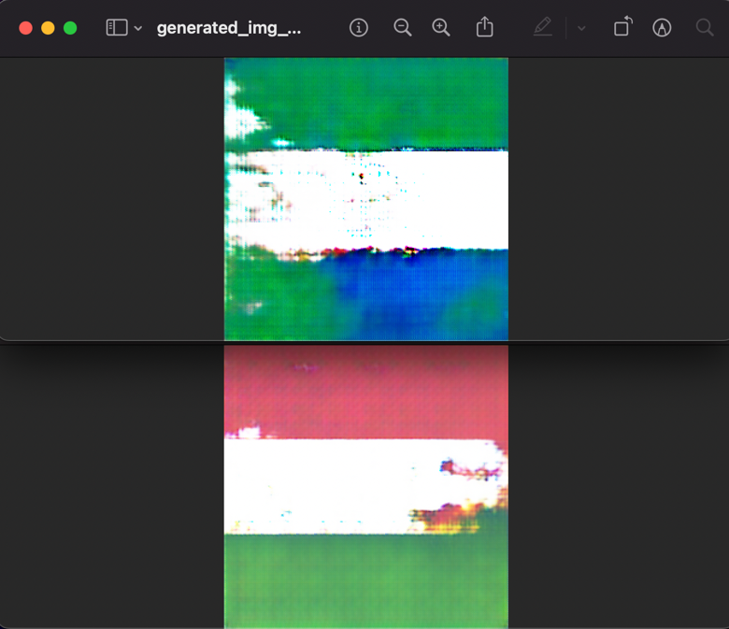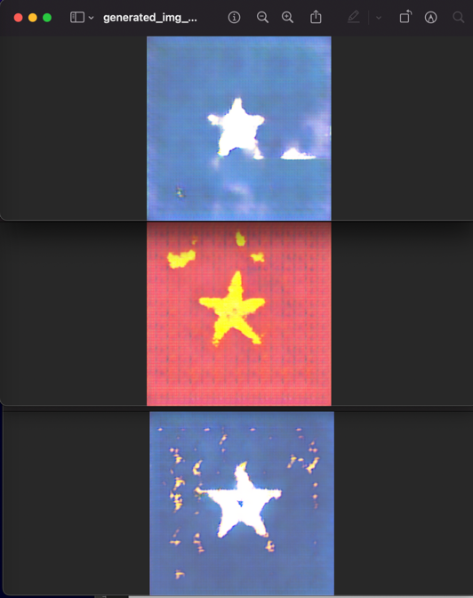

(Figure 04. Common features from different outcomes)

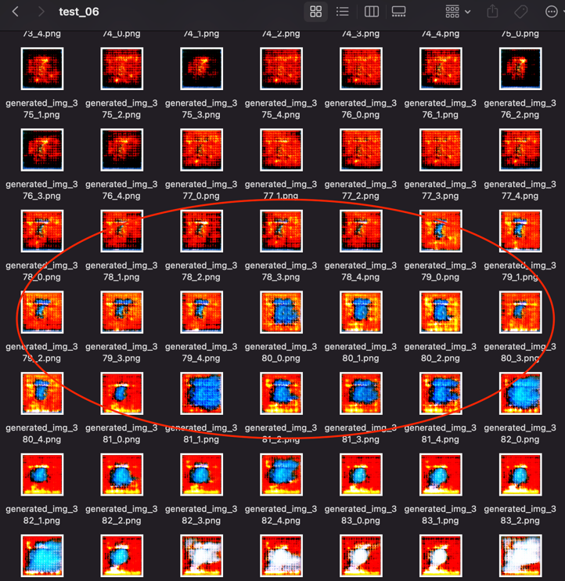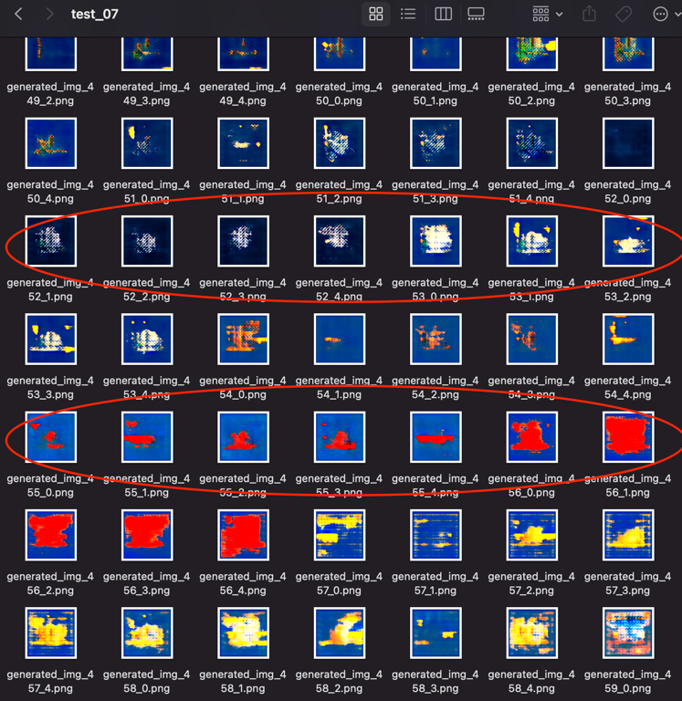

(Figure 05. Learning pattern from different outcomes)

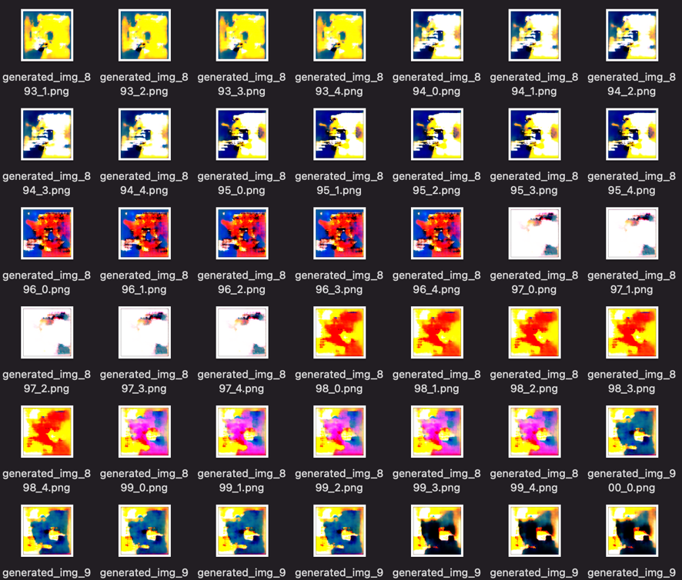

(Figure 06. Mode collapse)

**FlagGAN01 continue: StyleGAN2 ada**

The most important concept I have learned is transfer learning. I understood it as a technique that recycles previous models to perform a new task. In his blog (Prokin, 2018), he mentioned that the key parts of transfer learning are generalization and transferability and pretrained models like StyleGAN2 have the capability to employ generalized, low-level features in new conditions.

Figure 07-11 (below) indicates the powerful transfer learning techniques. At the beginning stage, I noticed that this model (ffhq 256) transfers some pre-trained features (human face) to new image (see fig.07) but will refine more accurate color diffusion and denoise pattern edges (see fig.11) after 16.7 hours training in total. Training A, B, and C (fig. 8-10) are interim results using different argumentation parameters. StyleGAN2 ada allows user to fine tune discriminator’s argumentation by selecting blit, geom, color, filter, noise, and cutout. For example, I did not activate color parameters (augs= “bg”) for the training A and the model picked up input color palate. Amongst all interim outcomes, I found Training B has the least precise pattern contours and most color noises. I assumed that this might be caused by argumentations like noise and filter (Training B, augs = “bgcfn”). For training C (augs = “bgc”), the result looks very similar to training A’s outcome except color accuracy. I also found that although Training C cost the least iterating time, the outline between different shapes (e.g. red bird pattern and white background) is the clearest and most distinguishable.

My FlagGAN01 final output (figure 11) shows a relative low-quality shapes and colors compared to their project “[This Flag Does Not Exist](https://thisflagdoesnotexist.com/)” (approx. 18h training). One possible reason is that my input is DCGAN-produced image with low resolution. Another reason is they might use different fine-tuning methods. Overall, through my practice, I have learned the idea of mode collapse and transfer learning and how to alter different parameters to achieve a better machine learning result.

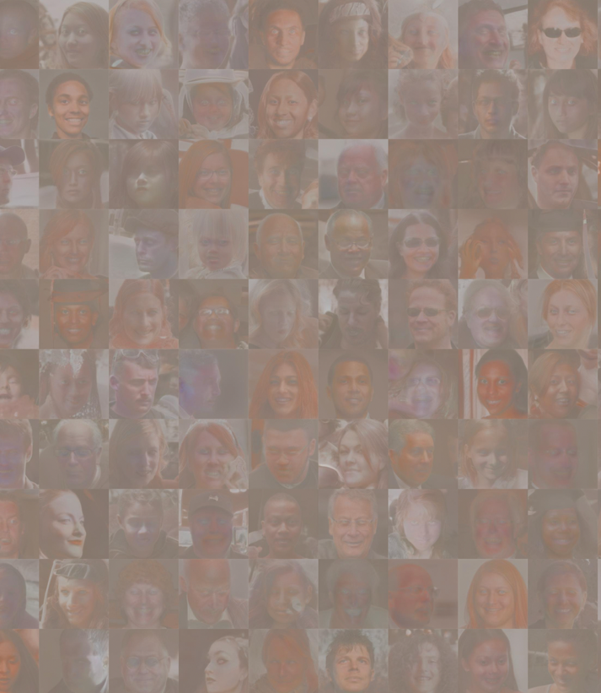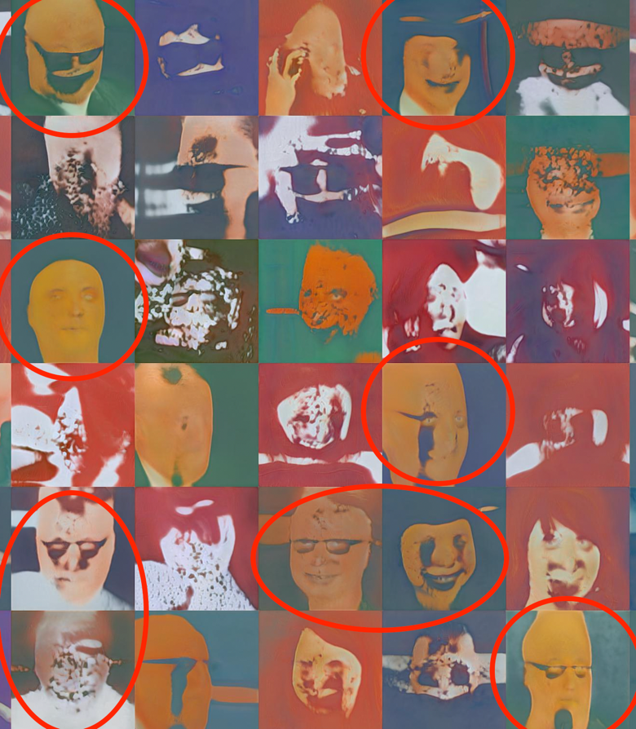

(Figure 07. Transfer learning start: human faces)

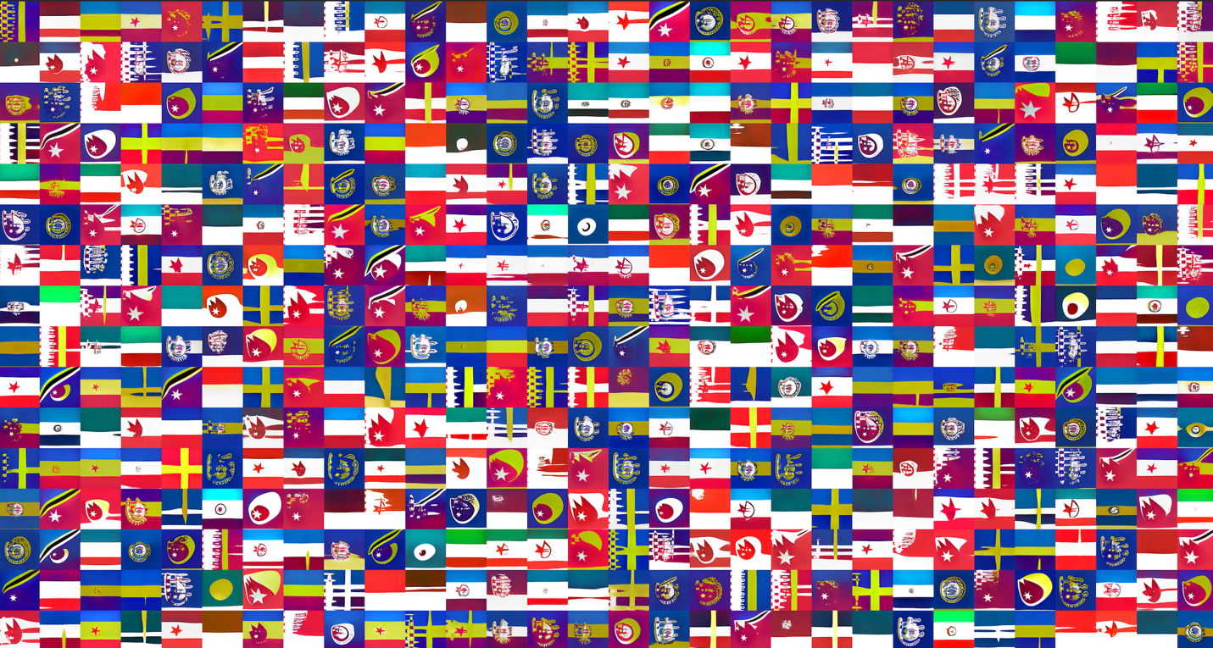

(Figure 08. Transfer learning A: first training result)

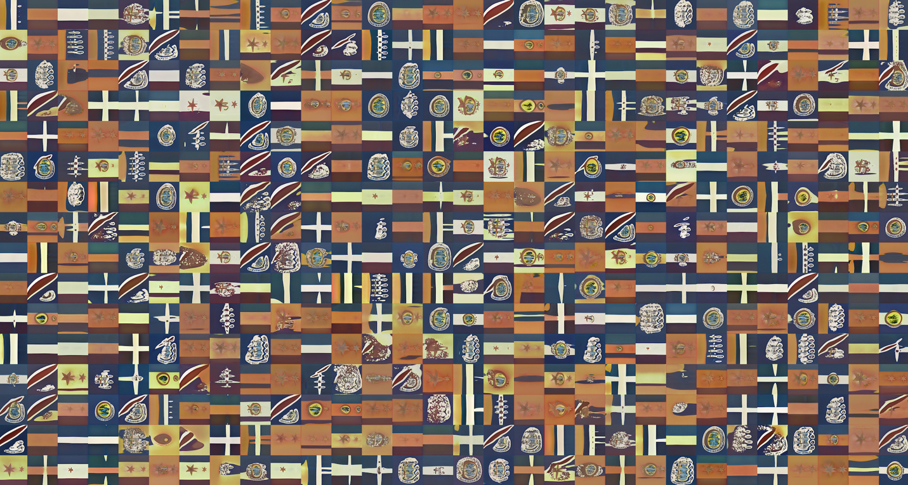

(Figure 09. Transfer learning B: second training result)

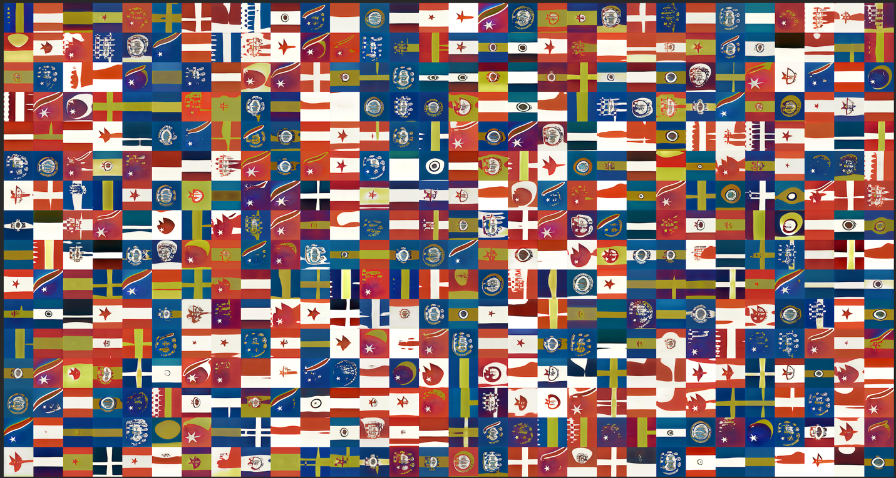

(Figure 10. Transfer learning C: third training result)

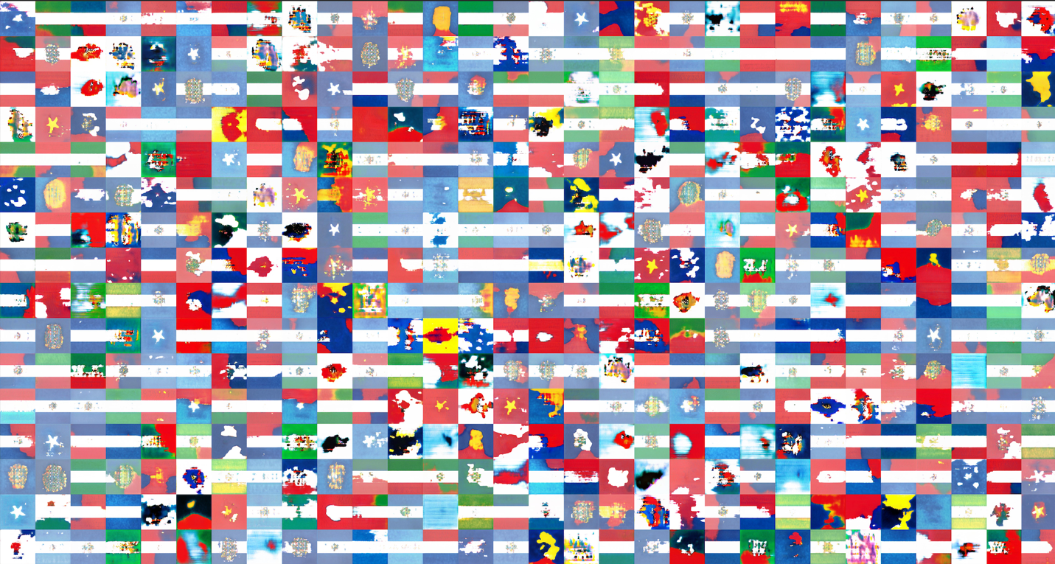

(Figure 11. Transfer learning end)

**Here is the gallery for some interesting artificial flags.**

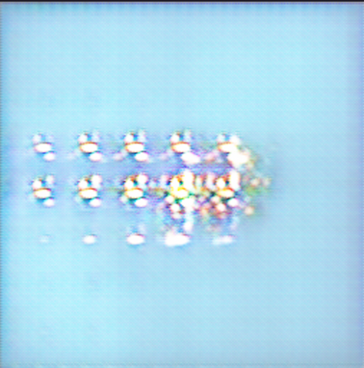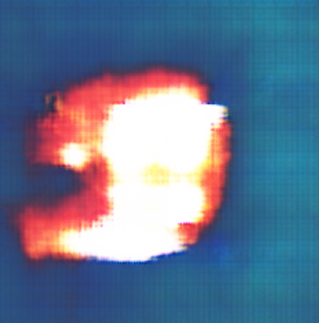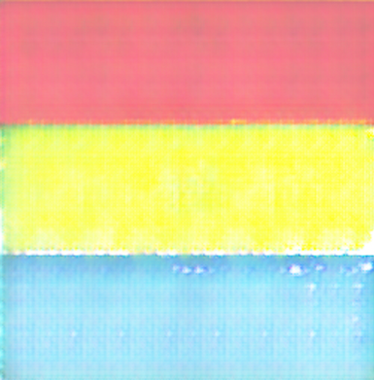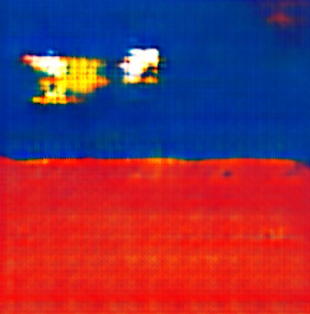

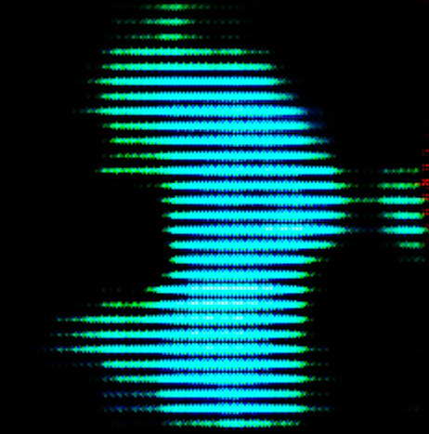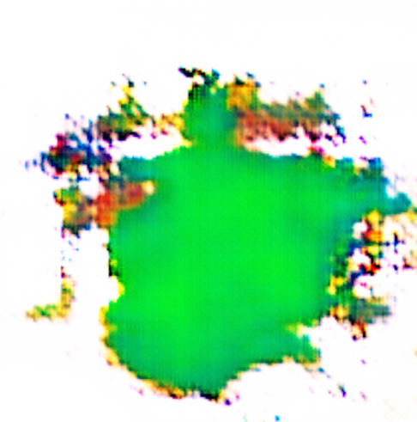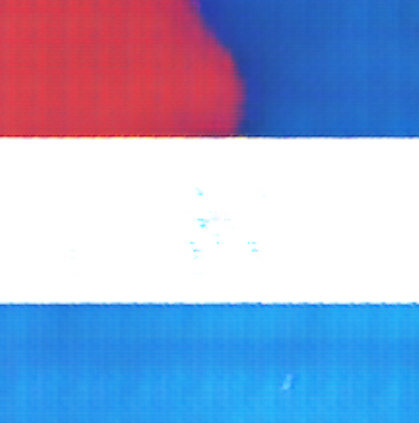

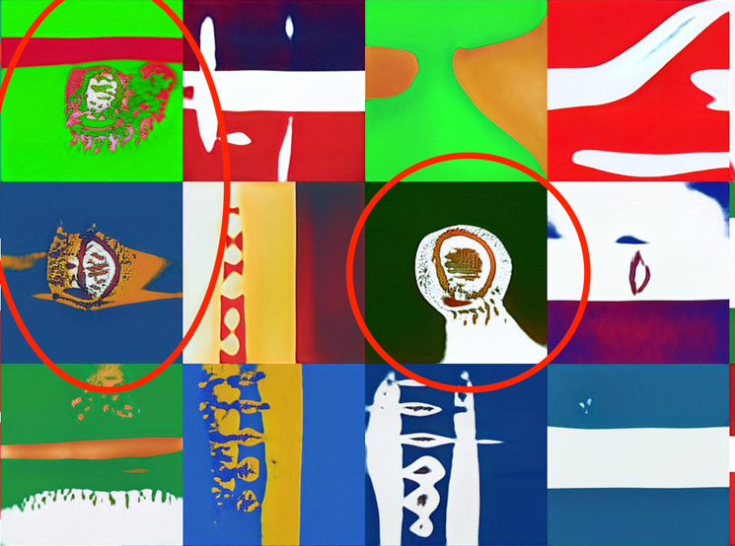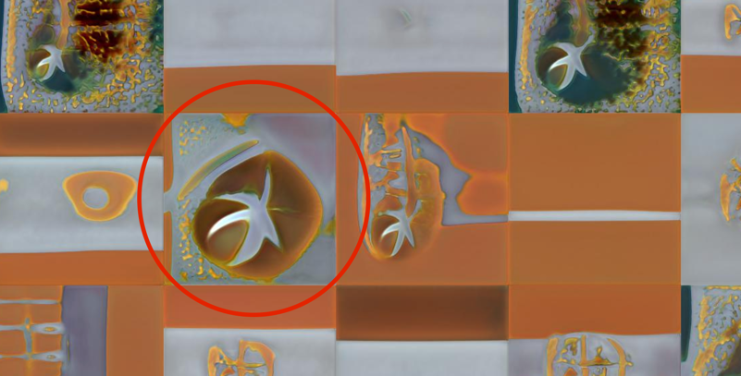

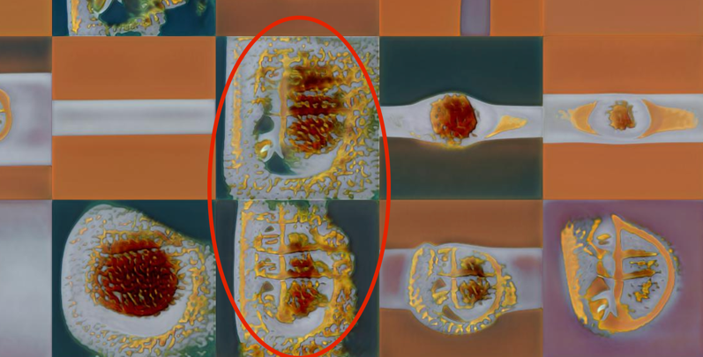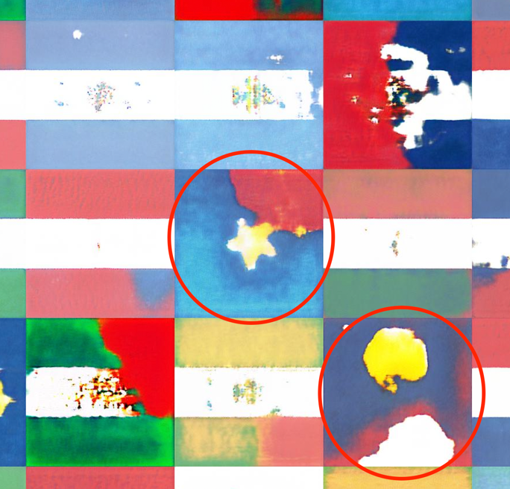

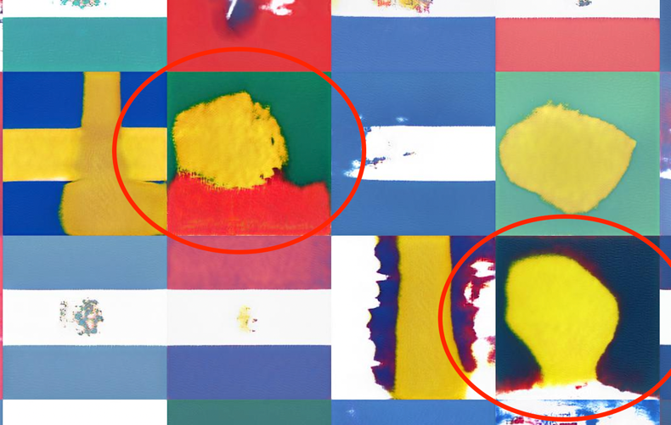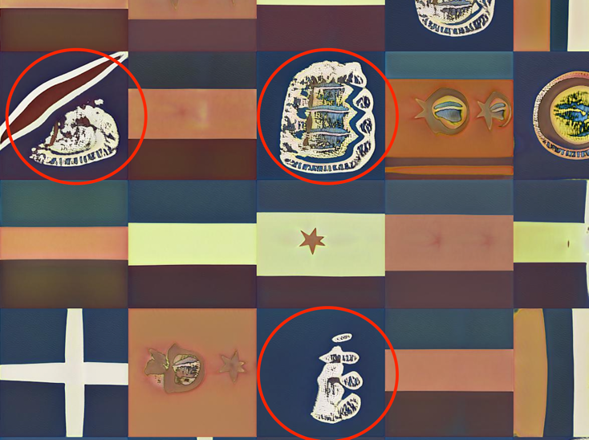

**Reference**

Lin, D.C.-E., 2020. 8 Simple Techniques to Prevent Overfitting. Medium. URL <https://towardsdatascience.com/8-simple-techniques-to-prevent-overfitting-4d443da2ef7d> (accessed 3.11.22).

Prokin, I., 2018. Transfer Learning — part 2: Zero/one/few-shot learning. dataswati-garage. URL <https://medium.com/dataswati-garage/transfer-learning-part-2-zero-one-few-shot-learning-8d23d2f8583b> (accessed 3.11.22).

Radford, A., Metz, L., Chintala, S., 2015. Unsupervised Representation Learning with Deep Convolutional Generative Adversarial Networks. arXiv:1511.06434 [cs].

Rashad, F., 2021. How to Train StyleGAN2-ADA with Custom Dataset [WWW Document]. Medium. URL <https://towardsdatascience.com/how-to-train-stylegan2-ada-with-custom-dataset-dc268ff70544> (accessed 3.13.22).